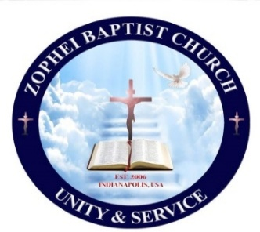

**Scholarship Application Form**

**Zophei Baptist Church**

1. **Personal Information**
2. Name of applicant: ……………………………………… Date of Birth ………………………
3. Address: …………………………………………………………………………………………………

Phone number: ………………………………………. Email ……………………………………

1. **Parent/Guardian Information**
2. Parent’s Names……………………………………………………………
3. Phone………………………
4. **Educational Information**
5. Name and address of the Institution:

…………………………………………………………………………………………………………………….

1. Phone …………………………………
2. Mark your degree Program: Bachelor, Master, Doctorate and or PhD.
3. Number of Credits Each Semester: ( )
4. Credits completed: ( )
5. Expected Graduation Date: ……………………………………………..

*If you do not graduate by the expected day, please explain:

…………………………………………………………………………………………………………………

…………………………………………………………………………………………………………………

1. **Requirements**
2. Every applicant must attach an official transcript to the application form.
3. The application deadline is October 5, 2025 (11:59pm). No exception.
4. Only this official application form will be accepted.
5. The application form may be submitted to [office@zbcindy.org](mailto:office@zbcindy.org) or ZBC office.

Signature: ………………………………….. Date: ………………………